**ANALYSING HOUSING PRICES IN METROPOLITAN AREAS OF INDIA**

**1. INTRODUCTION**

**1.1 Overview**

**Project Description:**

House price prediction in a metropolitan city in India is a valuable solution for potential home buyers, real estate agents, and investors. By leveraging historical sales data, property details, and location-specific information, a predictive model can accurately estimate house prices. The model's scalability, real-time updates, user-friendly interface, and transparency ensure it meets the needs of stakeholders. Integration capability, data privacy, and cost-effectiveness are also important considerations. By addressing these requirements, the prediction model provides reliable insights, empowering stakeholders to make informed decisions in the fast-paced real estate market.

**1.2 Purpose**

**(The use of the project):**

The purpose of analyzing housing prices in metropolitan areas of India serves a wide range of purposes, from helping individuals make informed decisions about housing to informing government policies and guiding real estate investments. It is a valuable source of information for various stakeholders in the housing market and the broader economy.

**2. PROBLEM DEFINITION & DESIGN THINKING**

**2.1 Empathy Map**

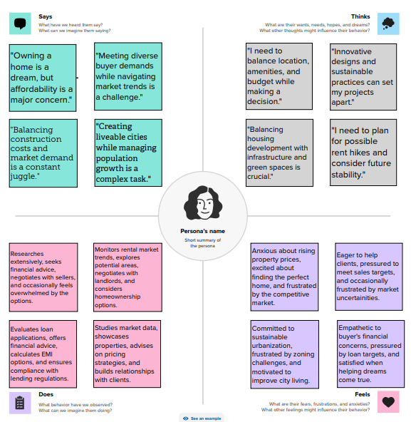

**2.2 Ideation & Brainstorming Map:**

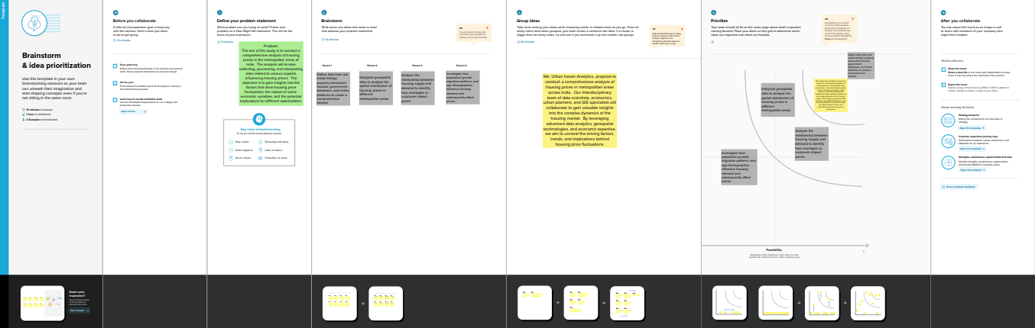

**3. RESULT**

**Final findings (Output) of the project along with screenshots.**

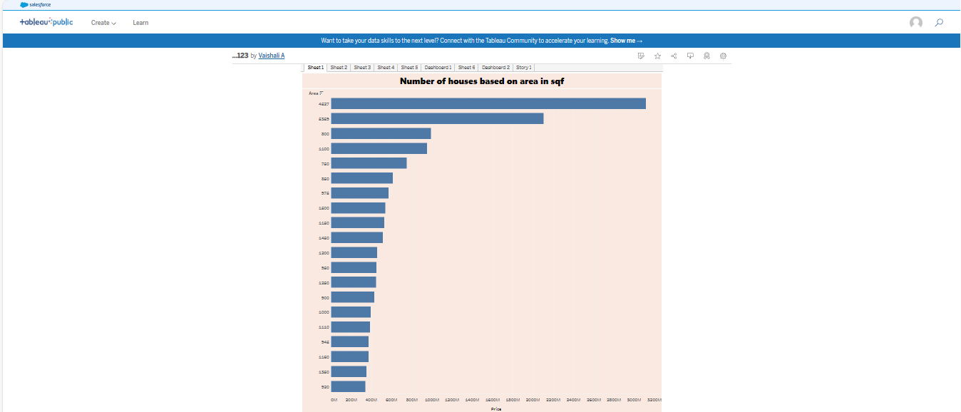

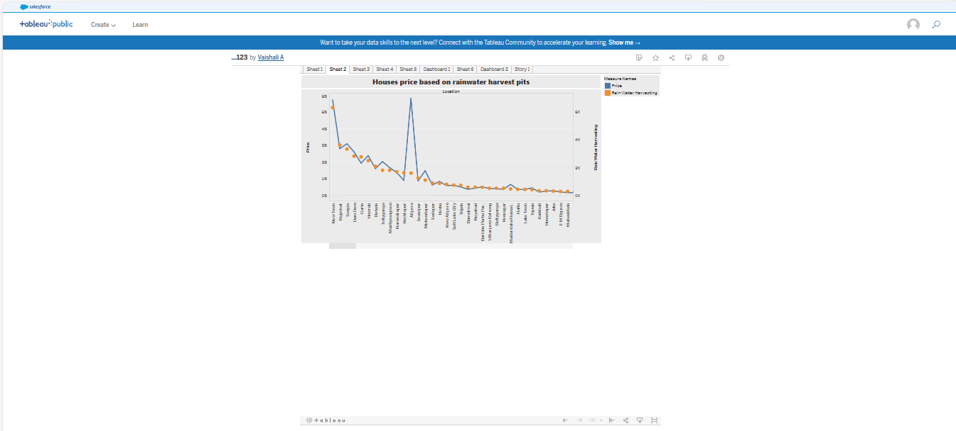

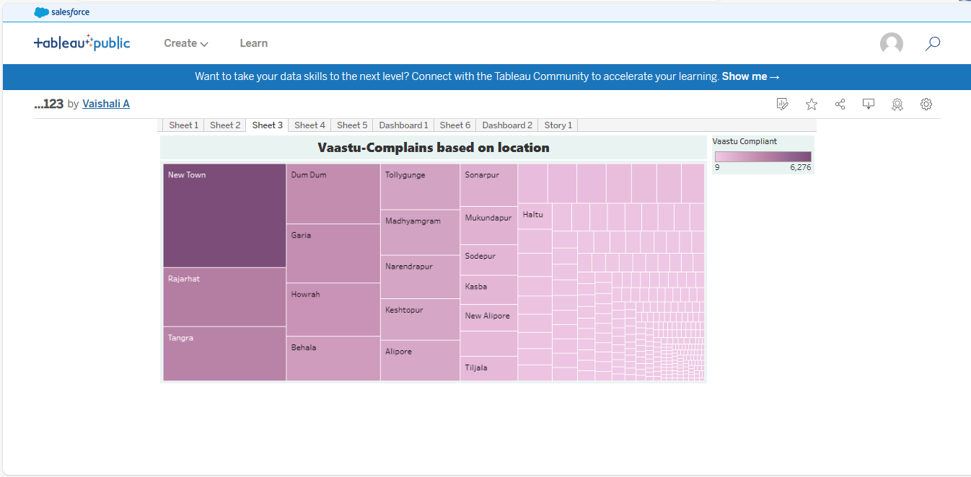

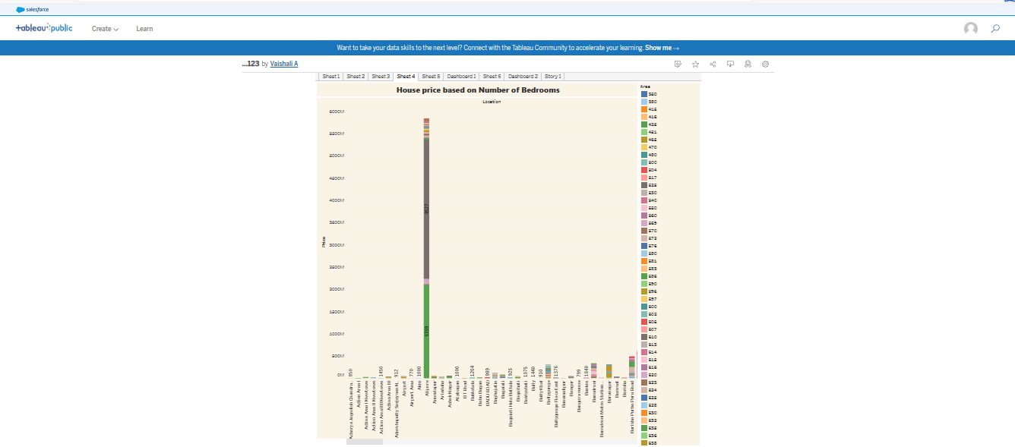

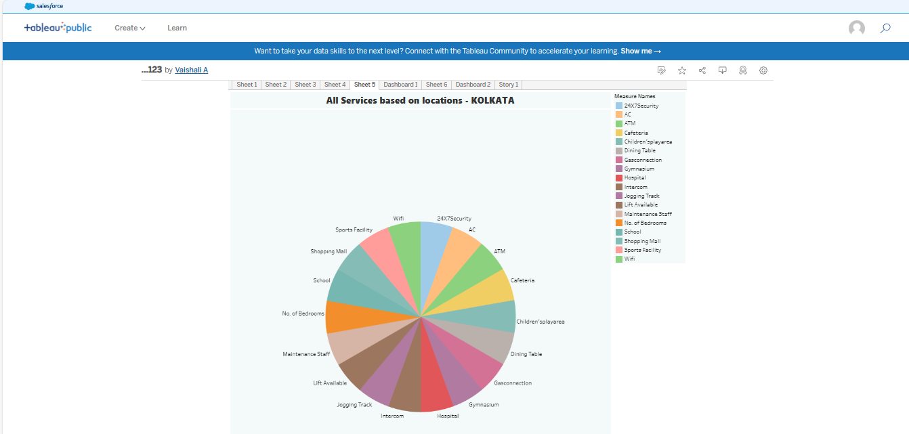

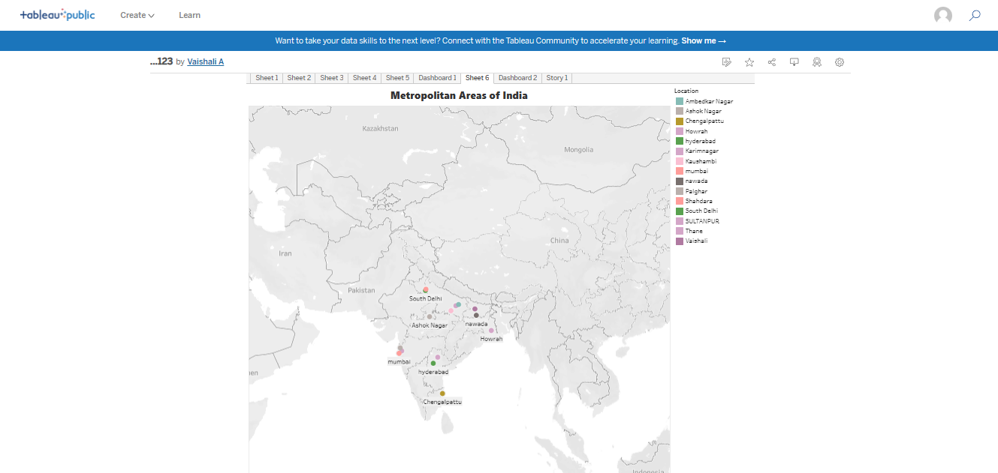

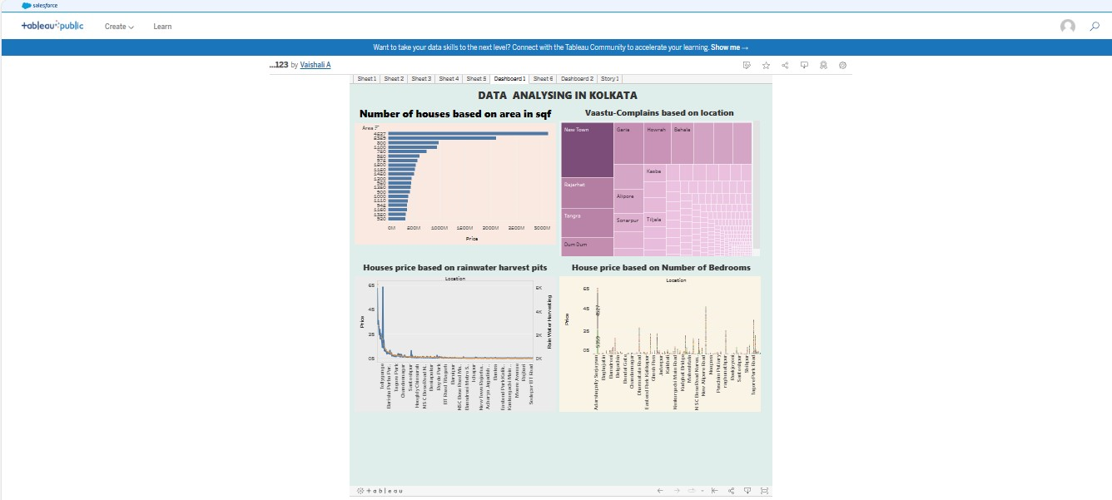

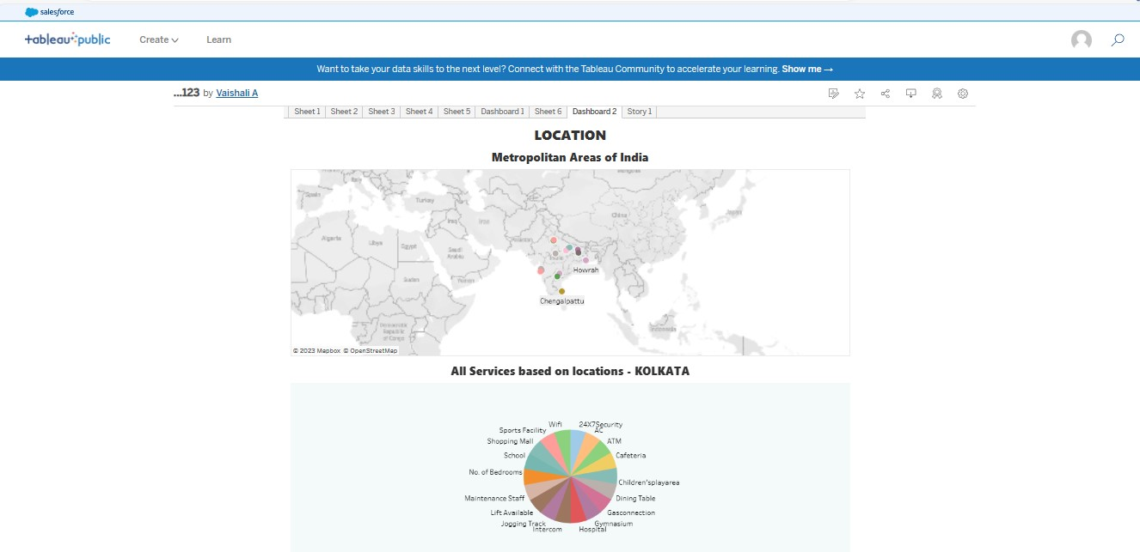

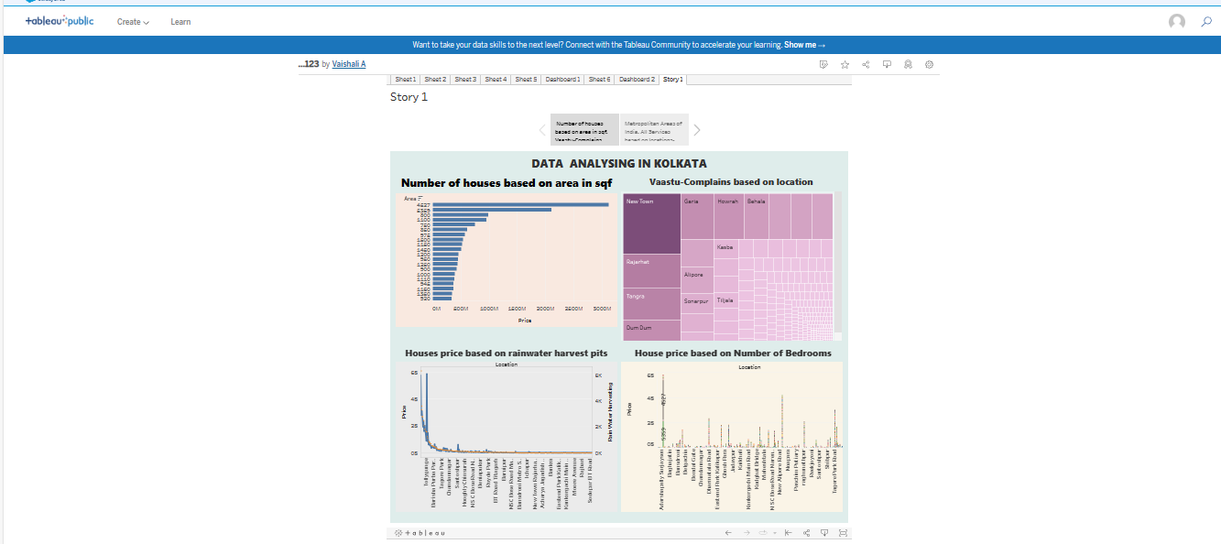

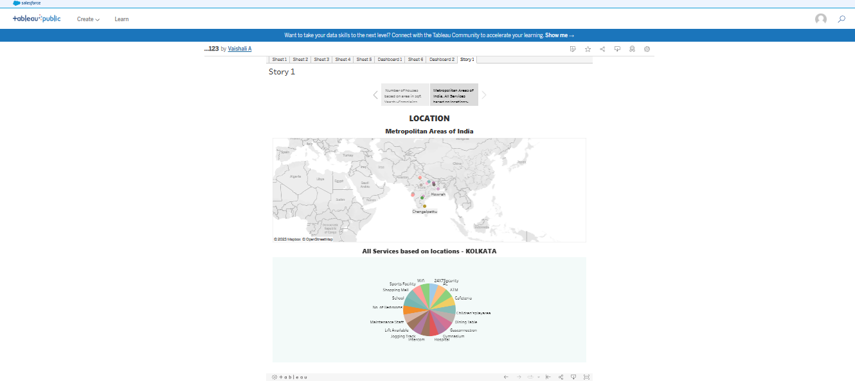

**4. Advantages & Disadvantages**

**4.1 Advantages:**

**The data that reflects the composition of a population, such as age, race, gender, income, migration patterns, and population growth.**

**Understand the spatial differences and analyses the income elasticity of prices, the role of construction costs and lending to the real estate industry by commercial banks.**

**The analysis demonstrates that high real construction cost and stricter regulations on new developments introduce unpaired supply restrictions.**

**The analysis proposed that how the raising prices would feed into higher demand for services like electricity and repairs, ultimately working their way into the overall inflation basket.**

**While housing prices are not part of the consumer price inflation basket, their effect is captured through construction and raw material prices, and analyst do not expect a slowdown and any time.**

**4.2 Disadvantages:**

**This analysis applies to markets that require some home equity contributions from buyers of housing services.**

**Existing literature is concerned about the risk of a housing bubble due to relaxed credit norms.**

**The dynamic of house prices in markets with higher owner equity requirements vary from high-leverage markets.**

**5. Application:**

**The influence of wealth effects is examined using novel data sets.**

**Understanding trends in regional house prices and whether they converge to a single steady state or form clusters are important issues.**

**Used to examine the dynamics of house prices in metropolitan cities in an emerging economy.**

**The analysis is to characterize the house price dynamics and the spatial heterogeneity in the dynamics.**

**Identify the parameters influences the housing shortage in rural areas than the urban areas.**

**6. Conclusion:**

**The long-term elasticity of house prices to aggregate household deposits varies considerably across cities. Among the given dataset of various cities, average house process remained highest in Mumbai and the lowest in Meerut. In addition, many cities in India are characterized by lower residential house prices than the national average. Residential house prices in three metro cities such as Kolkata, Hyderabad and Ahmedabad, remained even lower than the national average.**

**7. Future scope**

**The future scope of analyzing housing prices in Indian metropolitan areas, it's important to stay updated with the latest data sources, use advanced analytics and modeling techniques, and collaborate with experts in fields such as economics, urban planning, and data science. Additionally, keeping an eye on evolving market dynamics and government policies will be crucial for making informed decisions in this field.**

**8. Appendix:**

**Dashboard 1 link:**

[**https://public.tableau.com/views/___123_16958213106230/Dashboard1?:language=en-US&:display_count=n&:origin=viz_share_link**](https://public.tableau.com/views/___123_16958213106230/Dashboard1?:language=en-US&:display_count=n&:origin=viz_share_link)

**Dashboard 2 link:**

[**https://public.tableau.com/views/___123_16958213106230/Dashboard2?:language=en-US&:display_count=n&:origin=viz_share_link**](https://public.tableau.com/views/___123_16958213106230/Dashboard2?:language=en-US&:display_count=n&:origin=viz_share_link)

**Story board:**

[**https://public.tableau.com/views/___123_16958213106230/Story1?:language=en-US&:display_count=n&:origin=viz_share_link**](https://public.tableau.com/views/___123_16958213106230/Story1?:language=en-US&:display_count=n&:origin=viz_share_link)

**Google Drive video link:**

[**https://drive.google.com/file/d/1Lr-fiC6uWZjQ_866SAUDhxWuF8tf25wl/view?usp=drive_link**](https://drive.google.com/file/d/1Lr-fiC6uWZjQ_866SAUDhxWuF8tf25wl/view?usp=drive_link)